
SUNNAH REMEDIES
INSTITUTE OF PROPHETIC MEDICINE
Brand & Logo Guidelines
Version 1.0 · Logo System, Colour & Typography

GUIDELINES

Contents
01 The Brand Positioning and register
02 The Mark Meaning and symbolism
03 Primary Logo The core asset
04 Construction & Clear Space Geometry and breathing room
05 Minimum Sizes Legibility floor
06 The Logo Suite Icon variations
07 Lockups Horizontal, stacked, descriptor
08 Colour Palette and specification
09 Typography Libre Baskerville & Inter
10 Backgrounds & Placement Where the mark may sit
11 Misuse What never to do
12 File Index Every supplied asset

01 — THE BRAND

A single institution
Sunnah Remedies is a unified Institute of Prophetic Medicine — one premium institutional brand expressed through four interconnected pillars: the Institute, the Clinic, the Apothecary, and the Community. Every asset in this system exists to reinforce a single, coherent institutional experience, never four separate brands.
The register is deliberately secular-luxury: quiet, exact, and confident. It is benchmarked against houses such as Aesop, Aman, Jo Malone and Harvard Executive Education rather than faith-institutional or clinical-medical conventions. Restraint is the defining discipline — distinctiveness comes from real substance and craft, not decoration.
Principles that govern the identity
- One design system. One navigation model. One institution.
- Restraint over decoration — the absence of ornament means every element must earn its place.
- Real substance carries the brand: named authorship, dated work, credentials and citations, not aesthetic alone.
- The palette sits close to default AI-generated aesthetics, so distinctiveness must come from print-craft typography and genuine institutional detail.

02 — THE MARK

The mark and its meaning
 | The mark holds three elements within a single emerald field.  The arch — an apothecary lantern and a threshold: heritage, shelter, and considered care.  The droplet — the remedy itself, rendered in antique gold as the singular focal point.  The water — twin waves signalling purity, source, and the natural origin of what is offered.

The mark is fixed artwork. Its proportions, stroke weights and internal relationships must never be redrawn, rebuilt or approximated. Always place supplied files.

03 — PRIMARY LOGO

The primary logo
The primary logo is the full-colour mark on the Deep Emerald field: an ivory arch and waves with a single gold droplet. This is the preferred expression of the brand and should be used wherever colour reproduction and space allow.

Primary logo — full colour on Deep Emerald.
Why the emerald field is integral
The arch and waves are rendered in Warm Ivory. They read only against the emerald field. For this reason the full-colour mark is always presented on its emerald tile. On backgrounds other than emerald, use the single-colour variations shown in section 06 rather than lifting the ivory artwork onto a pale surface, where it would disappear.

04 — CONSTRUCTION & CLEAR SPACE

Construction
The mark is built on a square field divided into an even modular grid. The arch, droplet and waves align to this grid. The geometry is fixed — the diagram below is provided for reference and reproduction checking only.
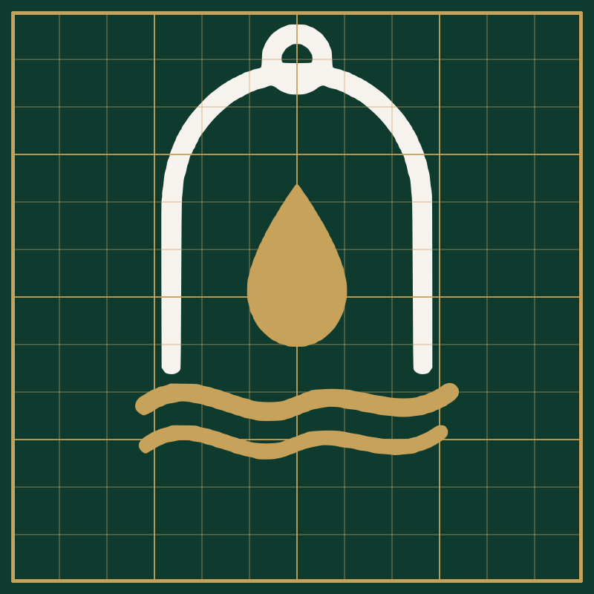
Construction grid — for reference only. Do not rebuild the mark from the grid.
Clear space
Protect the mark with clear space on all sides equal to X, where X is one quarter of the mark's width. No other logo, wordmark, caption or graphic element may enter this zone. When in doubt, give the mark more room, never less.

Minimum clear space = X on every side (X = ¼ of the mark width).

05 — MINIMUM SIZES

Minimum sizes
To preserve legibility of the droplet and the fine arch stroke, never reproduce the icon below the sizes shown. Below 24 px the waves begin to close up; 16 px is the absolute floor and is reserved for favicons and interface chrome.
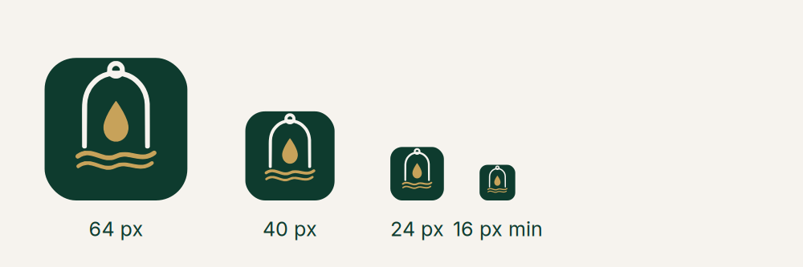
Recommended floors
Icon — digital | 24 px minimum (16 px for favicon only)
Icon — print | 10 mm minimum width
Horizontal lockup — digital | 180 px minimum width
Horizontal lockup — print | 40 mm minimum width
Stacked lockup — print | 30 mm minimum width

06 — THE LOGO SUITE

The logo suite
Beyond the primary logo, the icon is supplied in a controlled set of single- and two-colour variations. Each has a defined purpose. Choose the variation by background, never by preference.
 | Primary — full colour  Default. Emerald field, ivory arch, gold droplet. Use wherever colour and space allow.
 | App icon — rounded  The primary mark on a rounded emerald tile for app icons and avatars.
 | Single-colour emerald  The whole mark in Deep Emerald on transparent. For light and ivory backgrounds.

06 — THE LOGO SUITE

The logo suite
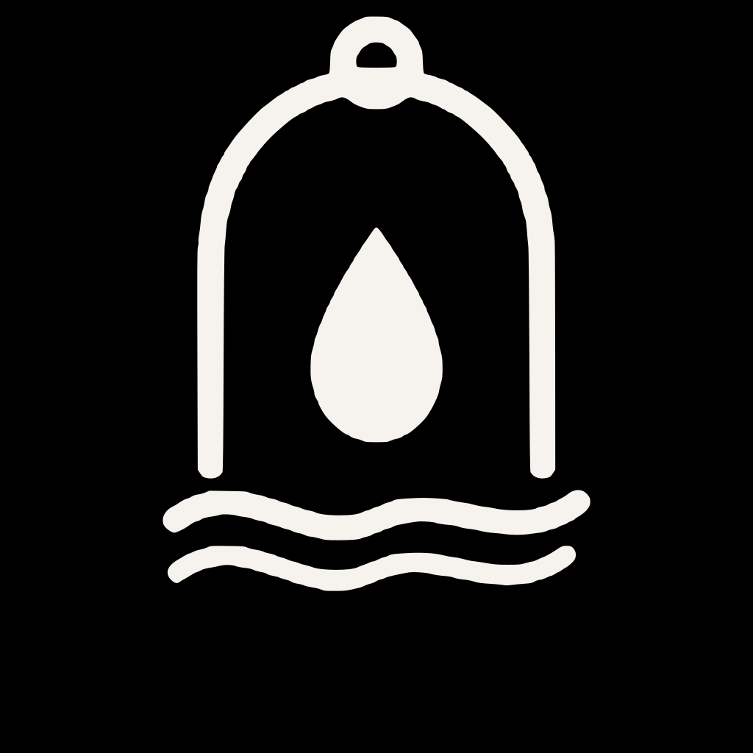 | Reversed — ivory  The whole mark in Warm Ivory on transparent. For emerald, photographic and dark backgrounds.
 | Two-colour on light  Emerald arch with gold droplet on transparent. A refined option for premium light-background stationery.
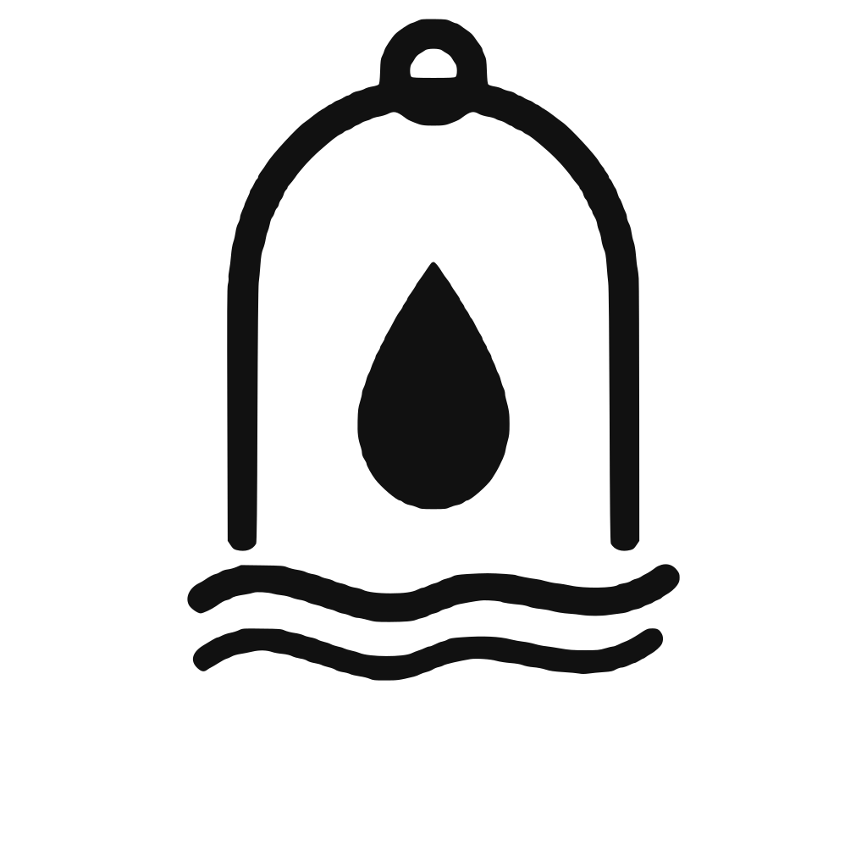 | Monochrome black  Single-colour black. For fax, engraving, embossing, and single-ink print.
 | Monochrome white  Single-colour white. For dark single-ink applications and overprinting.

07 — LOCKUPS

Lockups
When the mark appears with the name, use an approved lockup. The wordmark is set in Libre Baskerville, letterspaced; the descriptor line is set in Inter, widely tracked. Spacing between icon and wordmark is fixed within each file — never re-space, re-typeset or substitute the wordmark.
Horizontal lockup
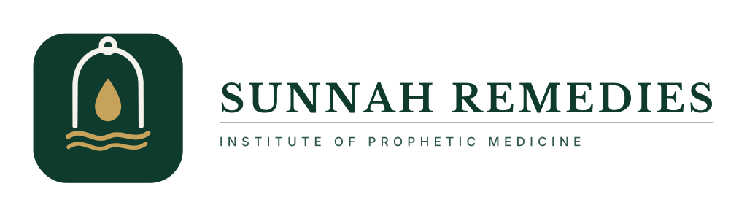
Horizontal lockup with descriptor — the primary signature for headers, letterheads and wide formats.
Stacked lockup

Stacked lockup with descriptor — for square and centred formats, signage and social avatars.

07 — LOCKUPS

Reversed lockups
On emerald and dark backgrounds, use the reversed lockups. The mark becomes ivory and the wordmark reverses to ivory for full contrast.
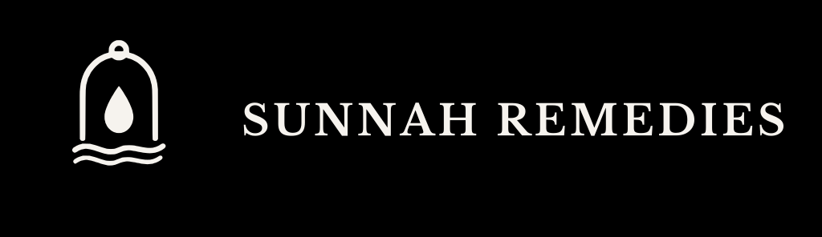
Horizontal lockup, reversed — on Deep Emerald.

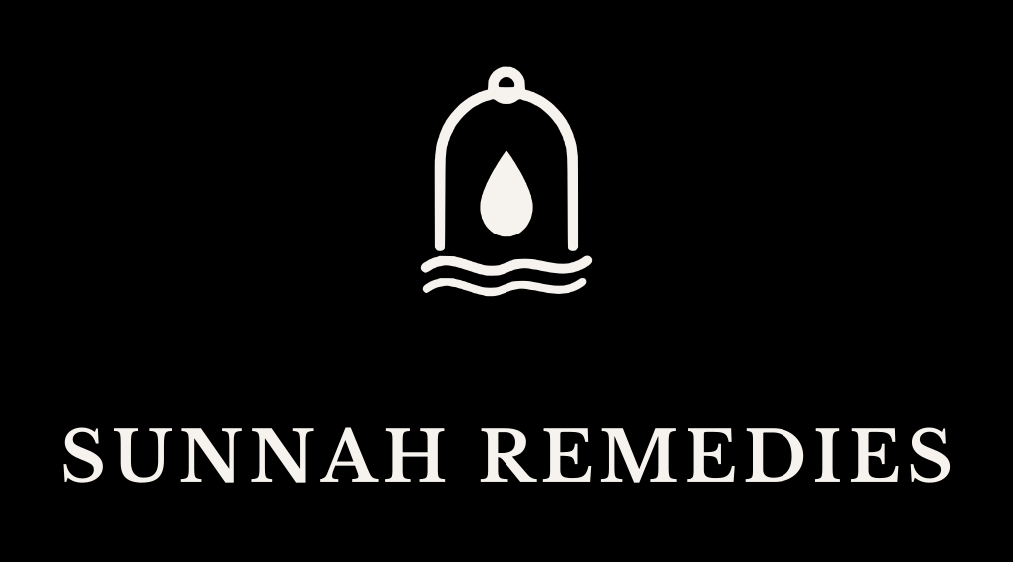
Stacked lockup, reversed — on Deep Emerald.

08 — COLOUR

Colour
Three colours carry the entire identity. They are used with discipline: emerald dominates, ivory provides ground and air, and gold is reserved for a single point of emphasis. Gold is an accent, never a fill — it should feel scarce.
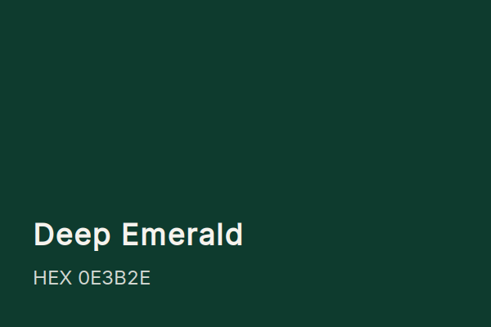 | 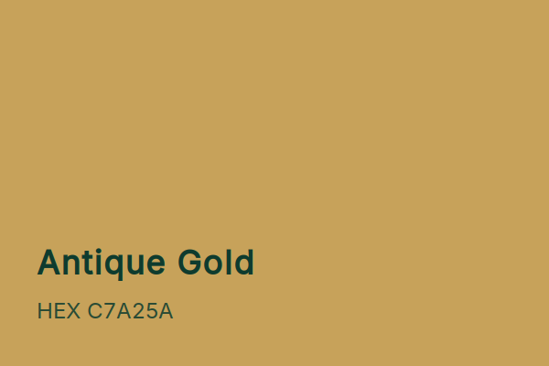 | 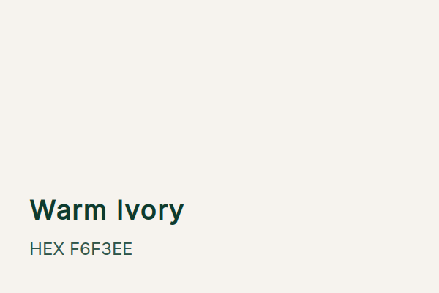

Colour | HEX | RGB | CMYK | Role
Deep Emerald | #0E3B2E | 14 · 59 · 46 | 84 · 45 · 68 · 52 | Primary / ground
Antique Gold | #C7A25A | 199 · 162 · 90 | 22 · 34 · 72 · 3 | Accent only
Warm Ivory | #F6F3EE | 246 · 243 · 238 | 3 · 3 · 6 · 0 | Ground / air

09 — TYPOGRAPHY

Typography
Two typefaces express the brand. Libre Baskerville, a print-rooted serif, carries names, titles and moments of authority. Inter, a precise neutral sans, carries descriptors, labels, body copy and interface text. The pairing signals scholarship and modern clarity at once.
Libre Baskerville — display & headings
Aa Bb Cc Dd Ee Ff Gg
SUNNAH REMEDIES
Used for the wordmark, headlines and titles. Set letterspaced in caps for the wordmark; sentence case for headings.
Inter — descriptor, labels & body
Aa Bb Cc Dd Ee Ff Gg
INSTITUTE OF PROPHETIC MEDICINE
Used for the descriptor line (widely tracked, uppercase), captions, labels and all running body text.

10 — BACKGROUNDS & PLACEMENT

Backgrounds & placement
The mark must always sit on a background that gives it clear, comfortable contrast. Use the table below to choose the correct variation for the surface.
Background | Approved variation
Deep Emerald | Primary (full colour) or reversed ivory
Warm Ivory / white | Single-colour emerald, or two-colour on light
Mid / dark photography | Reversed ivory, or emerald holding panel
Single-ink light | Monochrome black
Single-ink dark | Monochrome white

On photography, place the reversed (ivory) mark over a calm, evenly toned area of the image, or set it within a solid emerald holding panel. Never place the mark over a busy or high-contrast region where the arch stroke would break up.

11 — MISUSE

What never to do
The mark's authority depends on absolute consistency. The following are prohibited without exception.
  Don't stretch or distort  Never scale disproportionately. Constrain proportions always. | 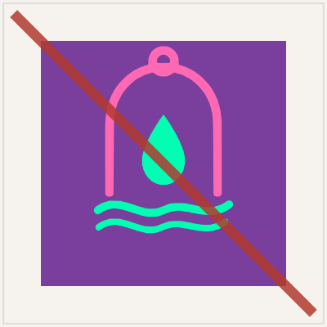  Don't recolour  Only the three brand colours. No off-palette fills, gradients or tints.
  Don't rotate or tilt  The mark sits square and upright. Never rotate, skew or angle it. | 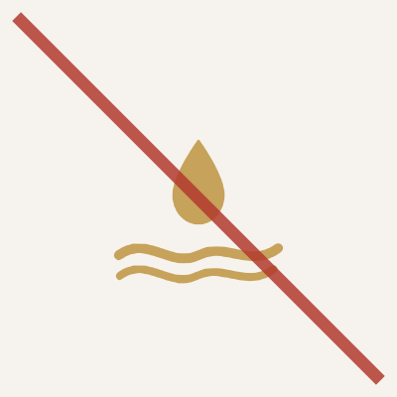  Don't drop the ivory mark on light  The ivory arch vanishes on pale grounds. Use the emerald single-colour version.
  Don't place on low contrast  Avoid backgrounds too close in tone to the mark or its field. |   Don't add effects  No shadows, glows, bevels, outlines or other embellishment.

12 — FILE INDEX

File index
Every asset is supplied as scalable SVG and as a high-resolution PNG. SVG is preferred for all digital and print use; PNG is provided for convenience and for fixed-size interface assets.
File | Description
icon-primary | Primary full-colour mark on emerald
icon-app-rounded | App icon — rounded emerald tile
icon-emerald | Single-colour emerald (light backgrounds)
icon-ivory-reversed | Reversed ivory (dark backgrounds)
icon-emerald-gold | Two-colour on light
icon-mono-black | Monochrome black
icon-mono-white | Monochrome white
favicon | Rounded favicon (16 / 32 / 48 px PNG included)
wordmark-emerald / -ivory / -black | Standalone wordmark, three colourways
lockup-horizontal-primary / -reversed / -descriptor | Horizontal signatures
lockup-stacked-primary / -reversed / -descriptor | Stacked signatures

Guidelines version 1.0 · Sunnah Remedies — Institute of Prophetic Medicine · Colours are specified for reference; verify CMYK against a physical proof before production printing.

